**LAB # 05**

**Task # 01: Create MVC api and validate it by using postman.**

**Solution:**

**Controller Class:**

namespace WebApplication7.Controllers

{

[Route("api/[controller]")]

[ApiController]

public class StudentController : ControllerBase

{

List<Student> st = new List<Student>()

{

new Student{id=1,name="Amjad",department="BSE"},

new Student{id=2,name="Ali",department="CS"},

new Student{id=3,name="Haider",department="BSE"},

new Student{id=4,name="Haris",department="CS"},

};

[HttpGet]

public IActionResult GetAllStudent()

{

if (st.Count == 0)

{

return NotFound("No student found");

}

return Ok(st);

}

[HttpGet("GetStudent")]

public IActionResult Get(int id)

{

var s = st.SingleOrDefault(x => x.id == id);

if (s == null)

{

return NotFound("No student found");

}

return Ok(s);

}

[HttpPost]

public IActionResult AddStudent(Student s)

{

st.Add(s);

if (st.Count == 0)

{

return NotFound("No student found");

}

return Ok(st);

}

[HttpPut("{id}")]

public IActionResult UpdateStudent(int id, Student s)

{

var student = st.FirstOrDefault(x => x.id == id);

if (student == null)

{

return NotFound("Student not found");

}

student.name = s.name;

student.department = s.department;

return Ok(st);

}

[HttpDelete]

public IActionResult DeleteStudent(int id)

{

var s = st.SingleOrDefault(x => x.id == id);

if (s == null)

{

return NotFound("No student found");

}

st.Remove(s);

if (st.Count == 0)

{

return NotFound("No student found");

}

return Ok(st);

}

}

}

**Student Model Class:**

public class Student

{

public int id { get; set; }

public string name { get; set; }

public string department { get; set; }

}

**Output:**

**Get Student By ID**  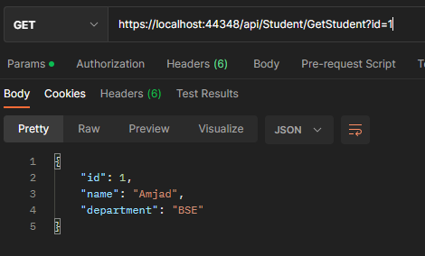

|  |  |
| --- | --- |
| **Post:** | **Get** |
| **Put** | **Delete** |